**Project Design Phase-II**

**Technology Stack (Architecture & Stack)**

|  |  |
| --- | --- |
| Date | 03 October 2022 |
| Team ID | PNT2022TMID52731 |
| Project Name | AI Powered- Food Demand Forecaster |
| Maximum Marks | 4 Marks |

**P.Subasri Raaja Anjana - CITC1907050**

**D.Jorryn - CITC1907017**

**S.V.Sakthivel -CITC1907037**

**M.Shibi -CITC1907044**

**Technical Architecture:**

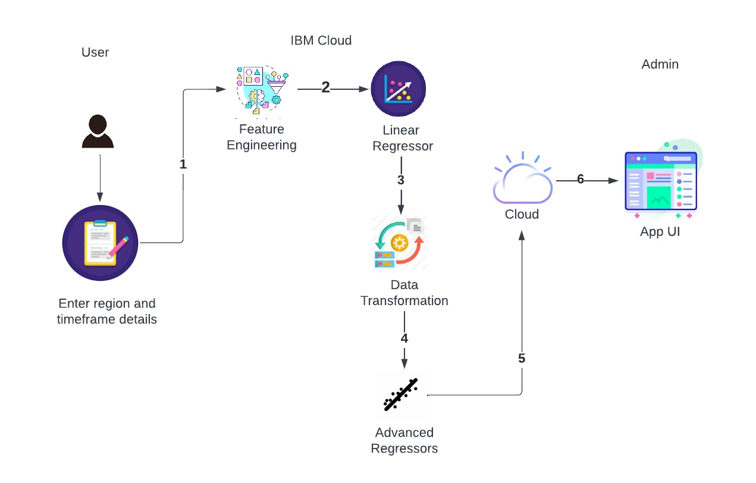

**Table-1 : Components & Technologies:**

|  |  |  |  |
| --- | --- | --- | --- |
| **S.No** | **Component** | **Description** | **Technology** |
|  | User Interface | User Interface for Food Demand Prediction which asks for registration credentials and requirement details. | HTML, CSS, JavaScript |
|  | Input and output | Gets inputs(region and timeframe) from user and displays the output using python. It uses get and post http methods in backend for processing. | Python |
|  | Libraries | Python libraries like Numpy, pandas, matplotlib, sklearn, seaborn for processing the dataset. | Google Colab |
|  | Algorithm | Linear model using linear regression and advanced model using XGBoost, CATBoost and LightBoost regression are implemented. | Regression models and ensemble techniques. |
|  | Database | Csv file |  |
|  | Machine Learning Model | Regression models are used to increase the speed at which data is processed and analysed. | Advanced Regression models. |

**Table-2: Application Characteristics:**

| **S.No** | **Characteristics** | **Description** |
| --- | --- | --- |
|  | Scalable Architecture | Highly-customizable infrastructure according to specific customer's needs |
|  | Availability | The system is monitored for bugs and so it is highly reliable. |
|  | Performance | Feature Engineering extracts valuable features from raw data which significantly improves the efficiency. |